**Question 1:**

**Write a function “insert_any()” for inserting a node at any given position of the linked list. Assume position starts at 0.**

**Code (In C Programming Language)[USING SINGLE LINKED LIST IMPLEMENTATION]:**

#include<stdio.h>

#include<stdlib.h>

struct Node **{**

int data**;**

struct Node**\*** next**;**

**};**

int size **=** 0**;**

Node**\*** getNode**(**int data**)** **{**

Node**\*** newNode **=** **new** Node**();**

newNode**->**data **=** data**;**

newNode**->**next **=** **NULL;**

**return** newNode**;**

**}**

void insert_any**(**Node**\*\*** current**,** int pos**,** int data**)** **{**

**if** **(**pos **<** 0 **||** pos **>** size **+** 1**)**

printf**(**"Invalid Position!\n"**);**

**else** **{**

**while** **(**pos**--)** **{**

**if** **(**pos **==** 0**)** **{**

Node**\*** temp **=** getNode**(**data**);**

temp**->**next **=** **\***current**;**

**\***current **=** temp**;**

**}**

**else**

current **=** **&(\***current**)->**next**;**

**}**

size**++;**

**}**

**}**

void printList**(**struct Node**\*** head**)** **{**

**while** **(**head **!=** **NULL)** **{**

printf**(**" %d"**,**head**->**data**);**

head **=** head**->**next**;**

**}**

printf**(**"\n"**);**

**}**

int main**()** **{**

Node**\*** head **=** **NULL;**

head **=** getNode**(**2**);**

head**->**next **=** getNode**(**4**);**

head**->**next**->**next **=** getNode**(**6**);**

head**->**next**->**next**->**next **=** getNode**(**8**);**

size **=** 4**;**

printf**(**"Linked list before insertion: "**);**

printList**(**head**);**

int totalInsert**,** i**,** data**,** pos**;**

printf**(**"How Many Time You want to insert? : "**);**

scanf**(**"%d"**,&**totalInsert**);**

printf**(**"\n"**);**

**for(**i **=** 0**;** i **<** totalInsert**;** i**++){**

printf**(**"Enter Number Value you want to input : "**);**

scanf**(**"%d"**,&**data**);**

printf**(**"Where is the position you want to insert (Started from Index 0) : "**);**

scanf**(**"%d"**,&**pos**);**

insert_any**(&**head**,** pos**+**1**,** data**);**

printf**(**"Linked list after insertion of %d at position %d: "**,**data**,**pos**);**

printList**(**head**);**

printf**(**"\n"**);**printf**(**"\n"**);**

**}**

**return** 0**;**

**}**

**Sample Output of The Program (Insert From Any Position):**

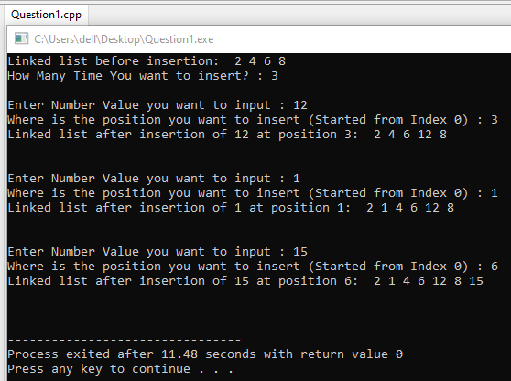

**Question 2:**

**Write a function “delete_beg()” for deleting a node from the beginning of the linked list.**

**Code (In C Programming Language)[USING SINGLE LINKED LIST IMPLEMENTATION]:**

#include<stdio.h>

#include<stdlib.h>

struct Node **{**

int data**;**

struct Node**\*** next**;**

**};**

Node**\*** delete_beg**(**struct Node**\*** head**)** **{**

**if** **(**head **==** **NULL)**

**return** **NULL;**

Node**\*** temp **=** head**;**

head **=** head**->**next**;**

**delete** temp**;**

**return** head**;**

**}**

void push**(**struct Node**\*\*** head_ref**,** int new_data**)** **{**

struct Node**\*** new_node **=** **new** Node**;**

new_node**->**data **=** new_data**;**

new_node**->**next **=** **(\***head_ref**);**

**(\***head_ref**)** **=** new_node**;**

**}**

int main**(){**

Node**\*** head **=** **NULL;**

push**(&**head**,** 12**);**

push**(&**head**,** 29**);**

push**(&**head**,** 11**);**

push**(&**head**,** 23**);**

push**(&**head**,** 8**);**

printf**(**"First Example: \n"**);**

printf**(**"Before Delete Beginning of Linked List: "**);**

**for** **(**Node**\*** temp **=** head**;** temp **!=** **NULL;** temp **=** temp**->**next**)**

printf**(**"%d "**,**temp**->**data**);**

printf**(**"\n"**);**

head **=** delete_beg**(**head**);**

printf**(**"After Delete Beginning of Linked List: "**);**

**for** **(**Node**\*** temp **=** head**;** temp **!=** **NULL;** temp **=** temp**->**next**)**

printf**(**"%d "**,**temp**->**data**);**

printf**(**"\n\n"**);**

printf**(**"Second Example: \n"**);**

printf**(**"Before Delete Beginning of Linked List: "**);**

**for** **(**Node**\*** temp **=** head**;** temp **!=** **NULL;** temp **=** temp**->**next**)**

printf**(**"%d "**,**temp**->**data**);**

printf**(**"\n"**);**

head **=** delete_beg**(**head**);**

printf**(**"After Delete Beginning of Linked List: "**);**

**for** **(**Node**\*** temp **=** head**;** temp **!=** **NULL;** temp **=** temp**->**next**)**

printf**(**"%d "**,**temp**->**data**);**

printf**(**"\n\n"**);**

printf**(**"Third Example: \n"**);**

printf**(**"Before Delete Beginning of Linked List: "**);**

**for** **(**Node**\*** temp **=** head**;** temp **!=** **NULL;** temp **=** temp**->**next**)**

printf**(**"%d "**,**temp**->**data**);**

printf**(**"\n"**);**

head **=** delete_beg**(**head**);**

printf**(**"After Delete Beginning of Linked List: "**);**

**for** **(**Node**\*** temp **=** head**;** temp **!=** **NULL;** temp **=** temp**->**next**)**

printf**(**"%d "**,**temp**->**data**);**

**return** 0**;**

**}**

**Sample Output 1 of The Program (Delete the Head of Linked List):**

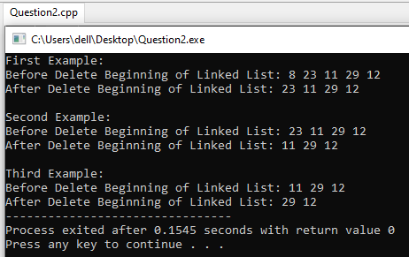

**Sample Output 2 of The Program (Delete the Head of Linked List):**

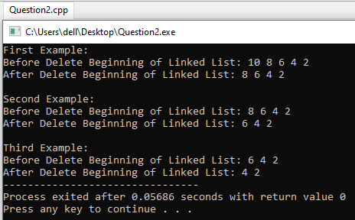

**Question 3:**

**Write a function “delete_end()” for deleting a node from the end of the linked list.**

**Code (In C Programming Language)[USING SINGLE LINKED LIST IMPLEMENTATION]:**

#include<stdio.h>

#include<stdlib.h>

struct Node **{**

int data**;**

struct Node**\*** next**;**

**};**

Node**\*** delete_end**(**struct Node**\*** head**){**

**if** **(**head **==** **NULL)**

**return** **NULL;**

**if** **(**head**->**next **==** **NULL)** **{**

**delete** head**;**

**return** **NULL;**

**}**

Node**\*** second_last **=** head**;**

**while** **(**second_last**->**next**->**next **!=** **NULL)**

second_last **=** second_last**->**next**;**

**delete** **(**second_last**->**next**);**

second_last**->**next **=** **NULL;**

**return** head**;**

**}**

void push**(**struct Node**\*\*** head_ref**,** int new_data**){**

struct Node**\*** new_node **=** **new** Node**;**

new_node**->**data **=** new_data**;**

new_node**->**next **=** **(\***head_ref**);**

**(\***head_ref**)** **=** new_node**;**

**}**

int main**(){**

Node**\*** head **=** **NULL;**

push**(&**head**,** 12**);**

push**(&**head**,** 29**);**

push**(&**head**,** 11**);**

push**(&**head**,** 23**);**

push**(&**head**,** 8**);**

printf**(**"First Example: \n"**);**

printf**(**"Before Delete Last of Linked List: "**);**

**for** **(**Node**\*** temp **=** head**;** temp **!=** **NULL;** temp **=** temp**->**next**)**

printf**(**"%d "**,**temp**->**data**);**

printf**(**"\n"**);**

head **=** delete_end**(**head**);**

printf**(**"After Delete Last of Linked List: "**);**

**for** **(**Node**\*** temp **=** head**;** temp **!=** **NULL;** temp **=** temp**->**next**)**

printf**(**"%d "**,**temp**->**data**);**

printf**(**"\n\n"**);**

printf**(**"Second Example: \n"**);**

printf**(**"Before Delete Last of Linked List: "**);**

**for** **(**Node**\*** temp **=** head**;** temp **!=** **NULL;** temp **=** temp**->**next**)**

printf**(**"%d "**,**temp**->**data**);**

printf**(**"\n"**);**

head **=** delete_end**(**head**);**

printf**(**"After Delete Last of Linked List: "**);**

**for** **(**Node**\*** temp **=** head**;** temp **!=** **NULL;** temp **=** temp**->**next**)**

printf**(**"%d "**,**temp**->**data**);**

printf**(**"\n\n"**);**

printf**(**"Third Example: \n"**);**

printf**(**"Before Delete Last of Linked List: "**);**

**for** **(**Node**\*** temp **=** head**;** temp **!=** **NULL;** temp **=** temp**->**next**)**

printf**(**"%d "**,**temp**->**data**);**

printf**(**"\n"**);**

head **=** delete_end**(**head**);**

printf**(**"After Delete Last of Linked List: "**);**

**for** **(**Node**\*** temp **=** head**;** temp **!=** **NULL;** temp **=** temp**->**next**)**

printf**(**"%d "**,**temp**->**data**);**

printf**(**"\n\n"**);**

**return** 0**;**

**}**

**Sample Output 1 of The Program (Delete the Last of Linked List):**

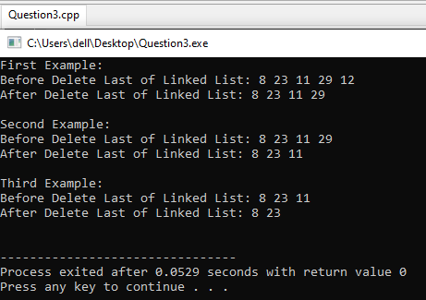

**Sample Output 2 of The Program (Delete the Last of Linked List):**

